Day1_Class,method,object

DAY1:
-------
1.Java Introduction
2.Class,Method,Object
3.Same package and Different package
4.Encapsulation

questions

1.What is platform independent?
once develop your java source code we can easily impelement into anykind of operating system

java compiler code can run on all operating system

Therefore a compiler is a program translates the source code for another program from a programming language into executable code.

2.Open source?
A software original source code is made freely availabe and redistributed&modified according to the requirement of the users.

open source software may be developed in public cooperative manner.

3.JDK,JRE,JVM?

JDK:Java Development Kit which provides the environment to develop and run the java code.It includes two main things development tools and jre to run the program

JRE:Java Runtime Environment is an installation package which provides the environment to only run not develop the java program onto your machine

JVM:Java Virtual machine is very important for both jdk and jre because it is contained in both.
whatever program you given in the jdk or jre it goes into jvm and jvm is responsible for executing the java program line by line it is also known as interpreter.

4.why we go for java?

java is a platform independent language,portable,code reusability,more secure.

5.What is the latest version of JDK and which version you are using in your project?

jdk 15 is latest release in the market in my project we are using jdk1.8 because enterprise level we using stable versions.

6.What is the latest version of eclispe and which version you are using in your project?

The latest version is eclipse 4.17 and we are using eclipse oxygen 3a.

7.Difference between c++ and java?

c++ is platform dependent for instance you developing java program for windows it cannot be reused in any operating system.we can use only on windows.

single task at a time

java is platform independent java code can be used in any kind of operating systems,code reusability,portable.

8.features of java?
object oriented language
platform independent
portable
simple
multithreading
robust

9.What type of tool you are using in your project to execute java?
In my project we are using eclipse ide is totally free of cost and also so many tools available in market such as intellj,netbeans etc..

10.Difference between class,method,object?

class:class is an single entity of an object.it is the combination of data and methods.it is template for object.

method:method is a set of code or block of code to perform certain operation or tasks.it will be write once and use multiple times

object:object is an instance of class.object is a realtime entity.object means storing a data into object.

11.Where object stores?
stack and heap are memory allocation for java.stack is used to store primitive data types,temporary variables,object address etcc

Heap is used to store the object in memory.

12.How to access one class method in to another package in different package?
we can access the class through via import method and then we call the class it will be working properly.

13.what is ancapsulation?
In encapsulation the variables are hidden from another classes and can be acccessed only through the method of their current class.

14.Coding standard to create project,class,method,package and object ?

pascal notation :Project name,class name

camal notation:package,methods

PRATICAL

1.QUESTION 1:
------------
Project :EmployeeDetails
Package :org.emp
Class :Employee
Methods :empId(),empName(),empDob(),empPhone(),empEmail(),empAddress()

Description:
Create an object for employee class and call above methods also follow the all coding standards.

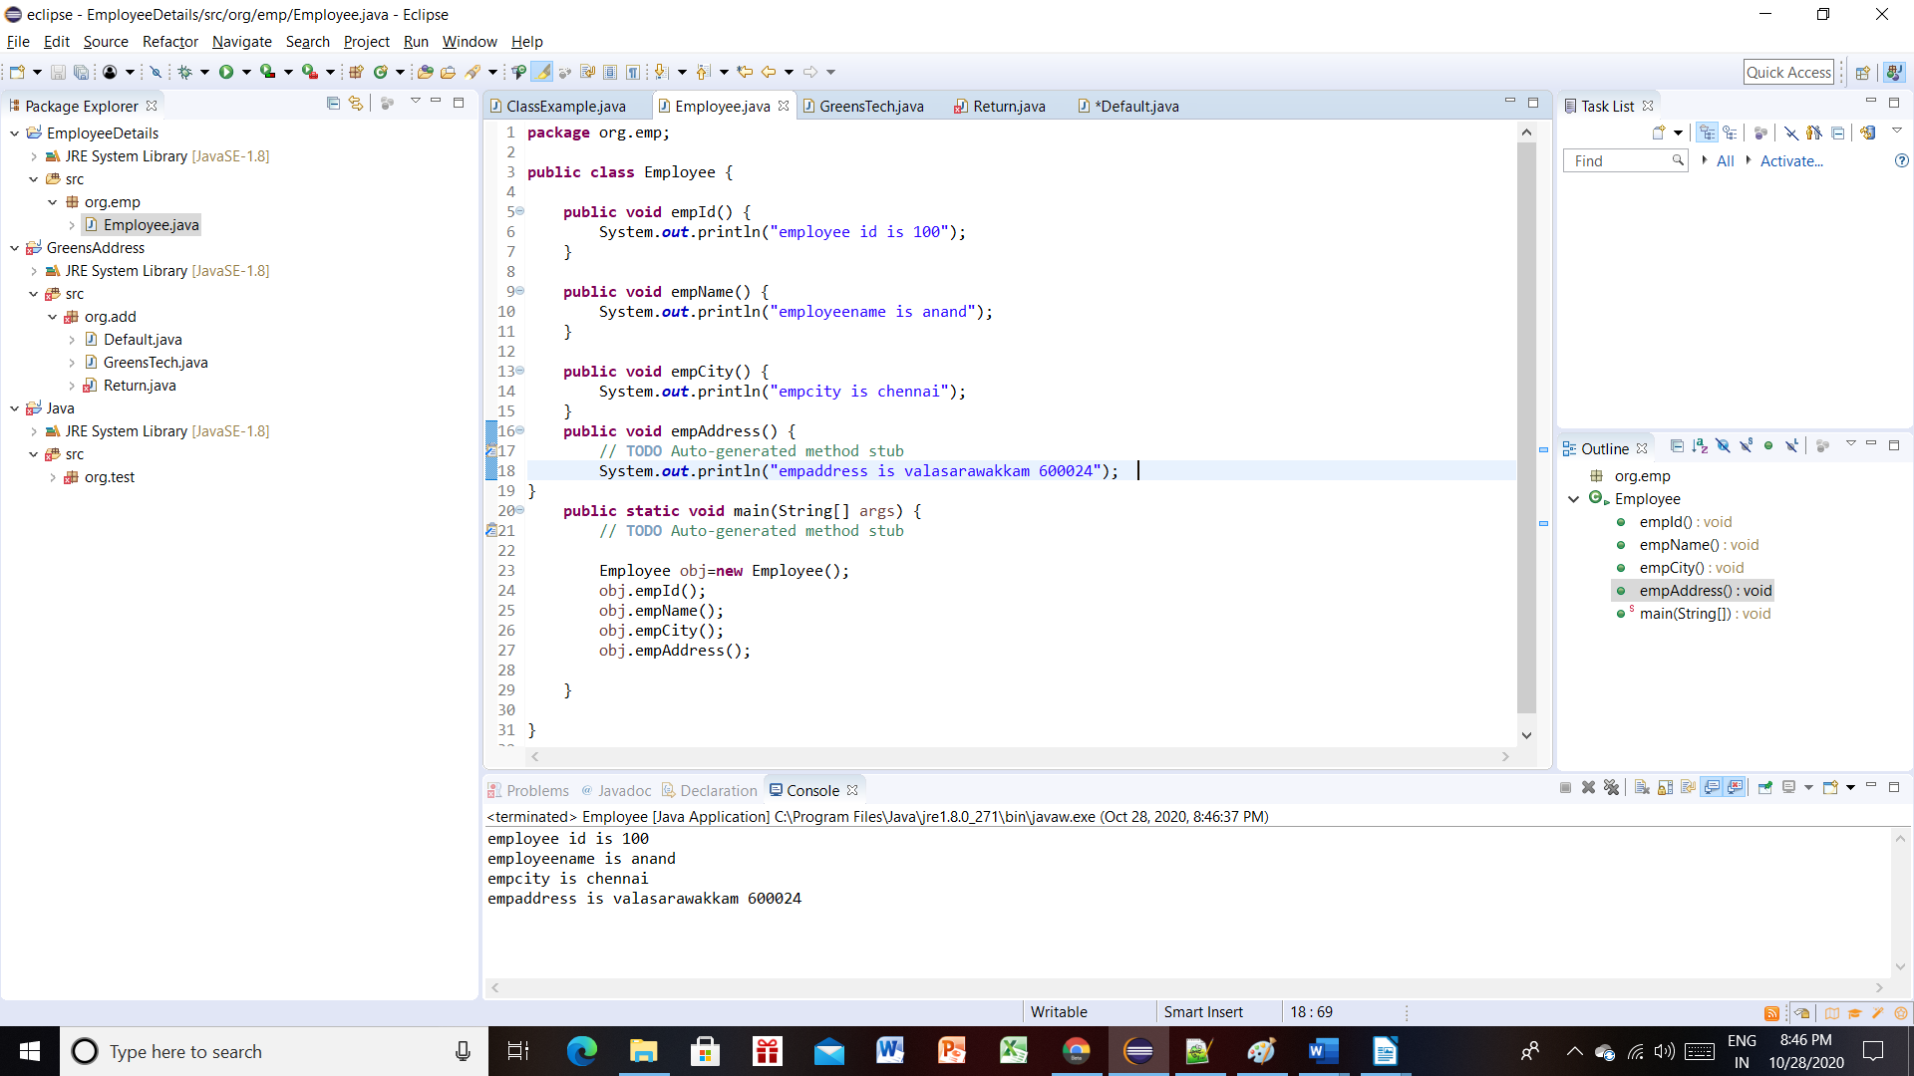

QUESTION 2:
-------------
Project :GreensAddress
Package :org.add
Class :GreensTech
Methods :greensOmr(),greensAdayar(),greensTambaram(),greensVelacherry(),greensAnnaNagar()

Description:
Create an object for GreensTech class and call above methods also follow the all coding standards

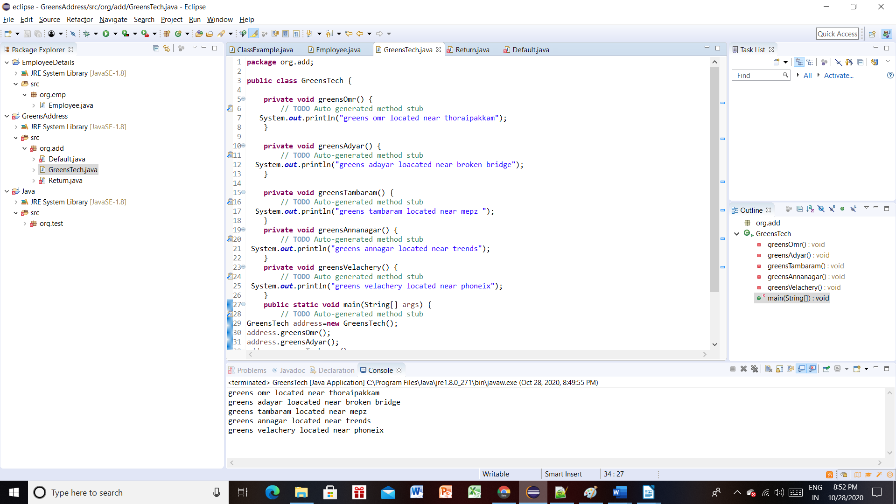

QUESTION 3:
------------
Project :CompanyDetails
Package :org.company
Class :CompanyInfo
Methods :companyName(),companyId(),companyAddress()

Description:
Create an object for CompanyDetails class and call above methods also follow the all coding standards.

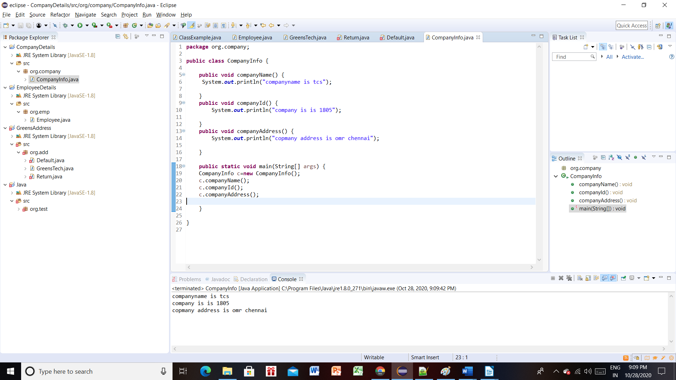

QUESTION 4:
-----------
Project :MyPhone
Package :org.phone
Class :PhoneInfo
Methods :phoneName(),phoneMieiNum(),Camera(),storage(),osName()

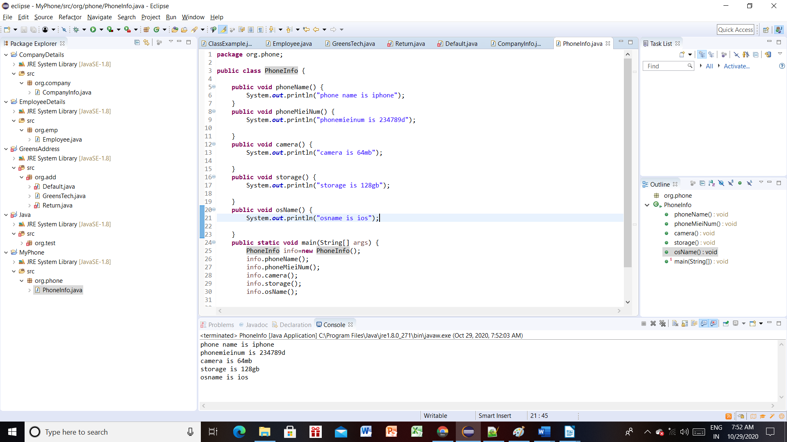

QUESTION 5:
------------
Project :LanguageDetails
Package :org.lang

Class :LanguageInfo
Methods :tamilLanguage(),englishLanguage(),hindiLanguage()

Class :StateDetails
Methods :southIndia(),northIndia()

Description:
Create an object for LanguageInfo and StateDetails inside the StateDetails class and call both classes methods also follow the all coding standards.

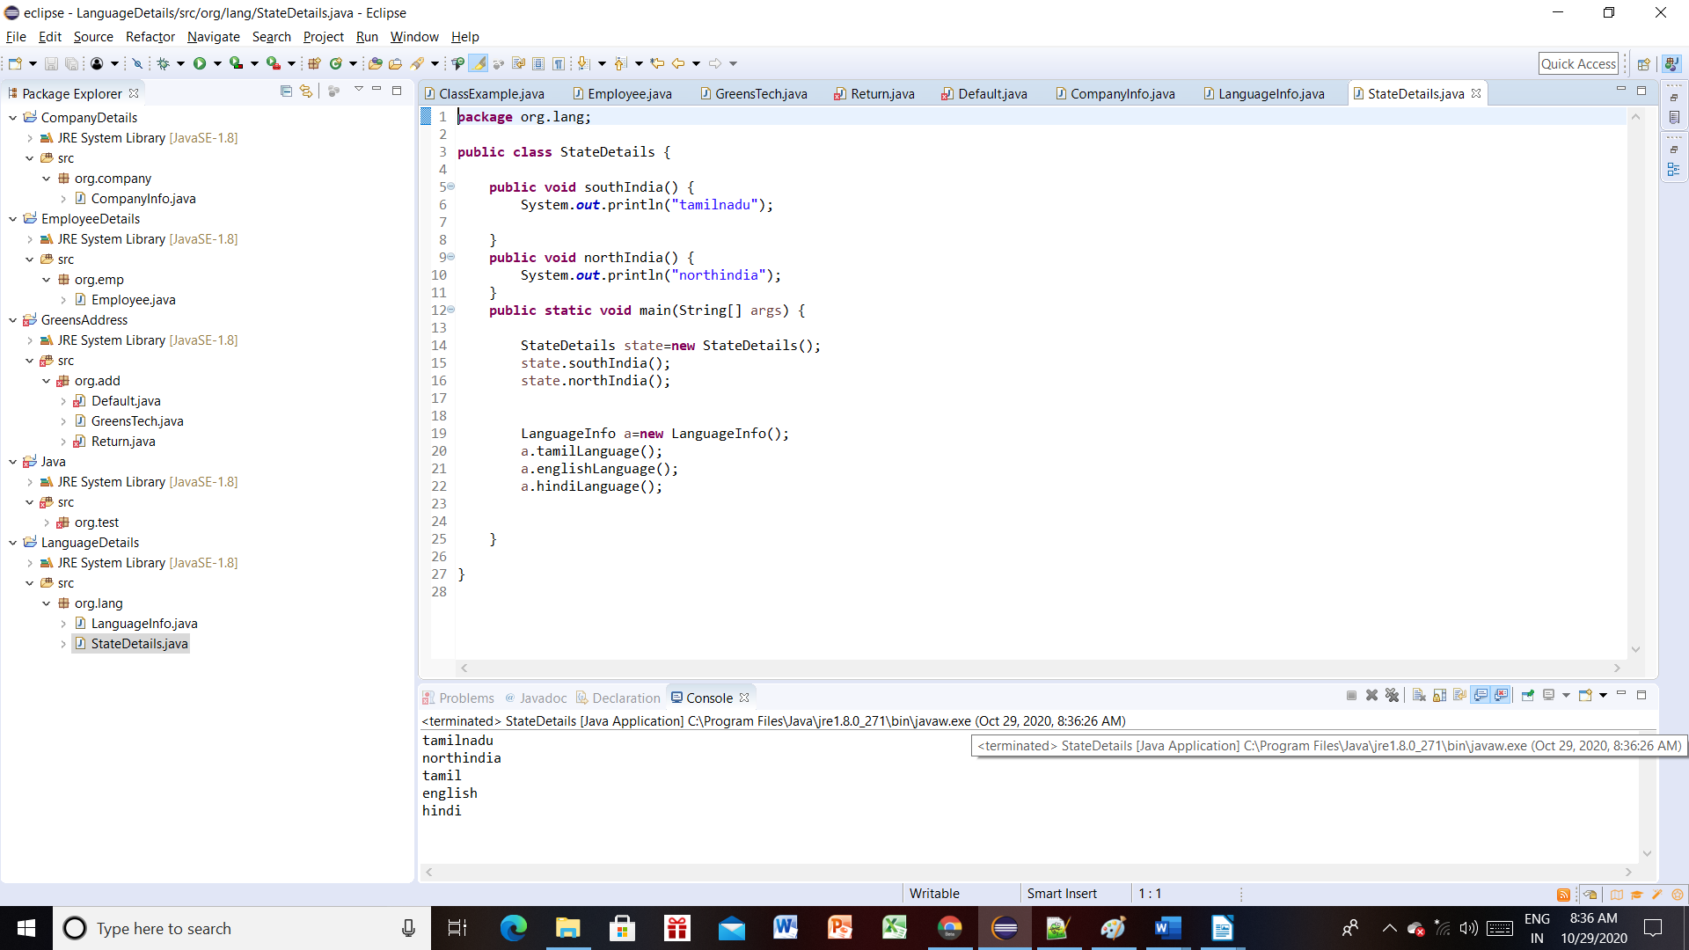

QUESTION 6:
-----------
Project :EmployeeInformation
Package :org.emp
Class :Employee
Methods :empName()

Package :org.company
Class :Company
Methods :companyName()

Package :org.client
Class :Client
Methods :clientName()

Package :org.project
Class :Project
Methods :projectName()

Description:
Create an object for all 4 classes inside the Employee class and call all classes methods also follow the all coding standards.
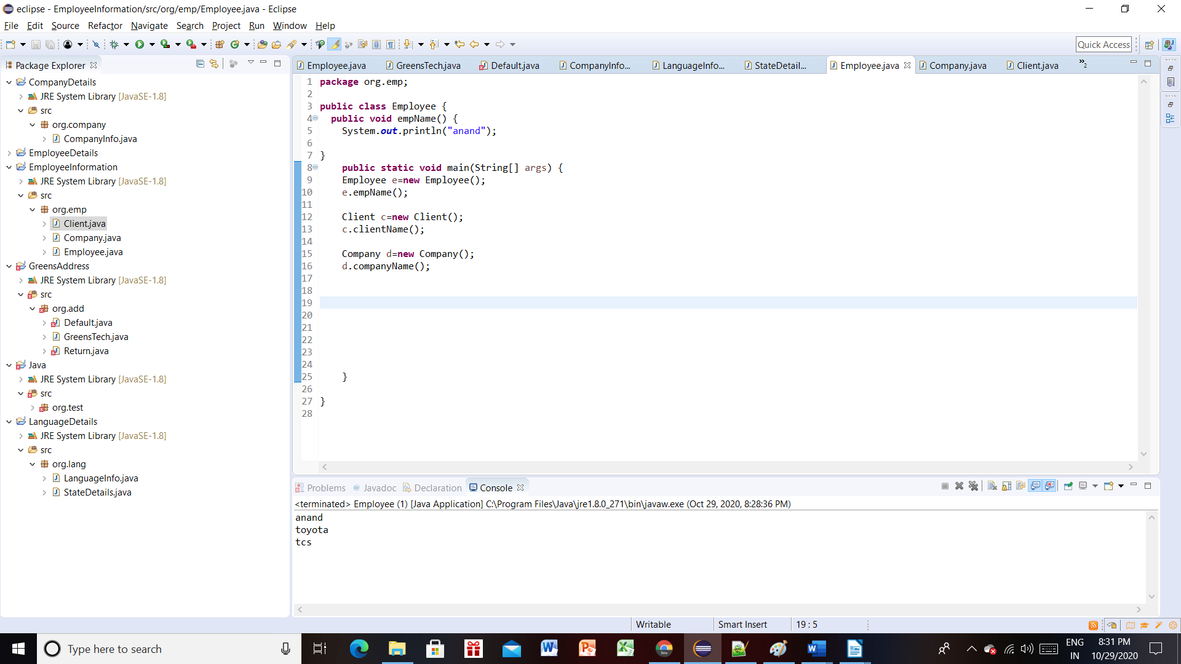

Project :PhoneDetails
Package :org.phone
Class :ExternalStorage
Methods :size()

Class :InternalStorage
Methods :processorName(),ramSize()

Description:
Create an object for ExternalStorage and InternalStorage inside the InternalStorage class and call both classes methods also follow the all coding standards.

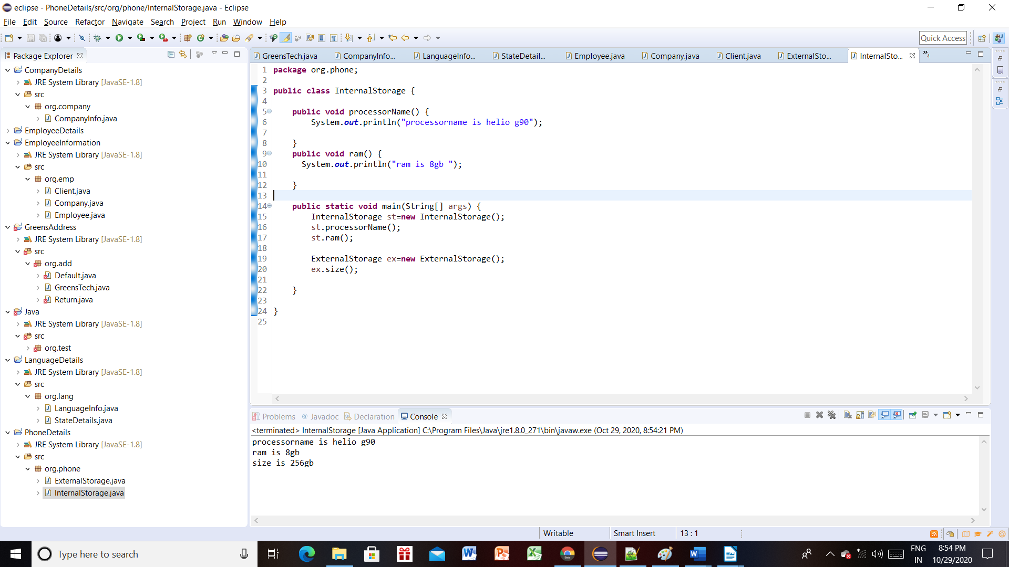

Project :TransportInformation
Package :org.transport
Class :Transport
Methods :TransportForm

Package :org.road
Class :Road
Methods :bike(),cycle(),bus(),car()

Package :org.air
Class :Air
Methods :aeroPlane(),heliCopter()

Package :org.water
Class :Water
Methods :boat(),ship()

Description:
Create an object for all 4 classes inside the Transport class and call all classes methods also follow the all coding standards.

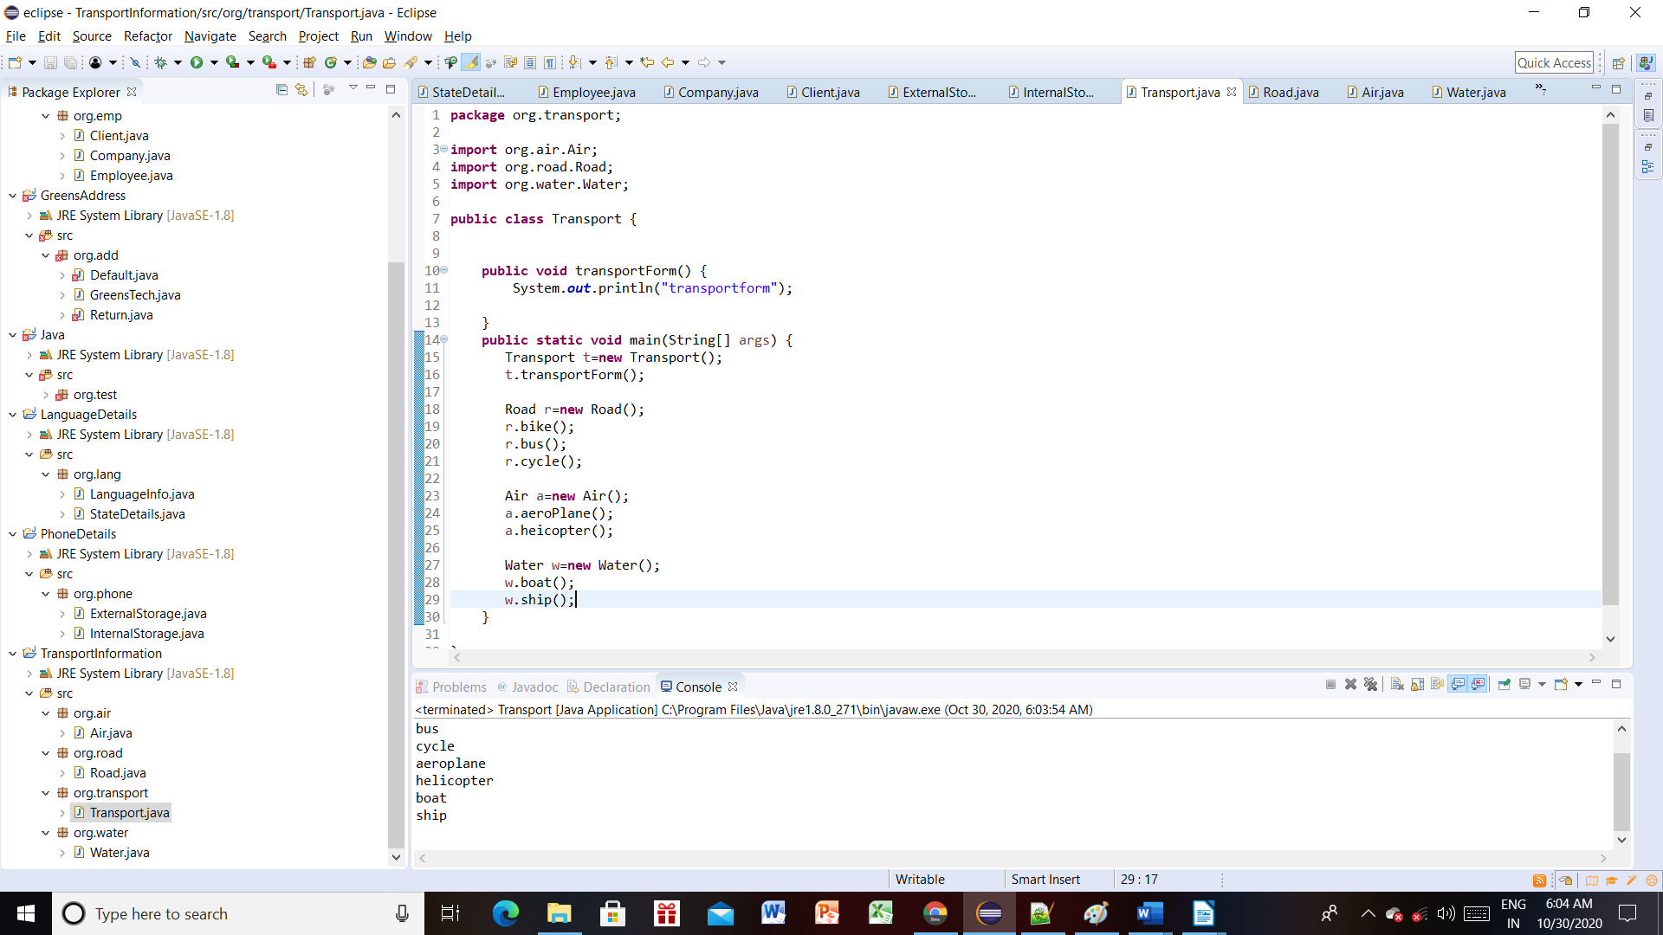

Project :NetworkInformation
Package :org.network
Class :Wifi
Methods :wifiName()

Class :MobileData
Methods :dataName()

Class :Lan
Methods :lanName()

Class :Wireless
Methods :modamName()

Description:
Create an object for all 4 classes inside the Wifi class and call all classes methods also follow the all coding standards.

